COVID Inquiry 2.0
Malcolm Roberts
LINK

1.5 hrs
Mary Jane Stevens
Nurse

Alan Dang - Pilot

2hrs 14 min
MYTHS (21)
FACTS x 1
This was quite good

2hr 20
Christine Dylan
Medical trafficking/organs

3hrs
Dr James Rowe
MRNA
Batches
No testing
Nano particles

4.5 hours
Dr Robert Brennan
Death spikes

4.45 in
Dr Chris Neil
Drs Truth
Informed consent
All EXPERIMENTAL

5hrs
Julian Gillespie

5hrs 55min
Dr Duncan Syme

6hrs 20min
Dr Gary Fettke
Incompetent
*Magna Carta

At 6hrs 28
Comparison
Common Law
National Law - AHPRA

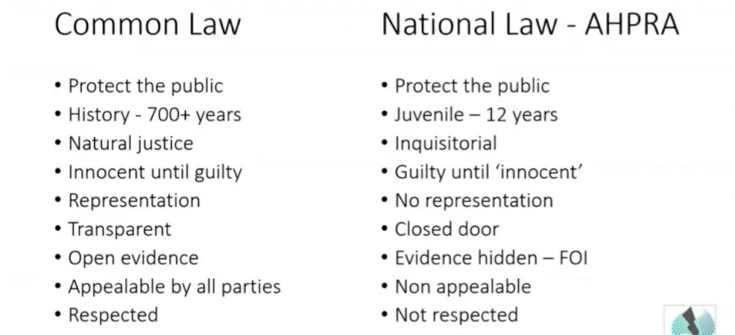

6hr 30 min
Dr Garry Fettke continued
Type 2 diabetes
PHD
reverse
No sugar
No processed food
Whistle-blowers

6hr 46min
Peter Fam from NSW
Human Rights Lawyer
Self determination
Exemptions list very brief
Rights exist
Aus - Human Rights treaty... protections- powers- rights to privacy no discrimination
Thought & opinion without interference
Part 3 article C ICCPR
Free consent
18 & 19 ICCPR Human Rights Commission Act includes treaties

Universal Human Rights!

7hr 13min
Julian Gillespie returns... discussion mainly with Malcolm
Very interesting

COAG
AHPRA
National cabinet
4th Tier Gov
Big Pharma connections
CORRUPTION
WHO - Bill & Melinda Gates $$$ to VAX

UN
AHPPC
AHPRA
Brendan Murphy
Morrison
Speculates- best interest to come down hard on Drs to get compliance

7hrs 40 min
Julian solutions Statement - 10 minutes
Proposes new legislation
Craig Kelly asks about suing public officers misfeasance
Illegal act
Damages consequences for public officers complicit

AHPRA & National board

EXPERIMENTAL

Act outside powers

Outrageous conduct

K CHAN'T!!! NSW
DATA shows UN V fairing better
Vaxxed filling hospital & DYING

Misfeasance personal suit - for harm to community

Malcolm asks re TGA banning Ivermectin- Julian hasn't yet investigated but assisted BIG PHARMA!!!

8hrs 21min
Dr Peter Perry
Psychiatrist
Human behaviour
Social engineering

Corrupt research
Injured removed from trials

8hr 40 approx
Dr Robert Brennan back
Cases- PCR

Treat R naught 🤔
Herd immunity = V
Novel = new response
WHO
Fluid goal posts

WHO 194 member states re centralised/global one health
Sustainable- tyrannical/all inclusive
Public Health used to push compliance

9hrs 2min in
Professor Iain
Benson

Medical ethics
AHPRA conduct
Private medical status disclosure
VAX status

Risk assessment
Between Dr & patient etc removed
Visitors even when dying
Basic relationships
Dignity
Government closing International borders

Informed consent
New medication- no risk information no ingredient.. Drs not even informed
AHPRA overturn exemptions & removed practitioners
Nuremberg code
AHPRA asked no response
TB more infectious no requirements re status

Vax injuries
Under reporting

Conflicts of interest

LAW
Aus culture

9hrs 32
Dr Gary Fettke returns

Solutions- health
Covid not problem HEALTH IS!!!
Metabolically unwell society
EAT HEALTHY

Sugar
Carbs
Veg oils

Obesity

Processed food

Public Health Vic
Hardly a mention of Obesity & diabetes

Overnight improve metabolic health
Whole foods

1992 explosion cereals & grains

Guidelines- ok soft drinks & junk food 🙄

Red meat decreased

Alcohol- essential through Covid
T lymphocytes
Reduce immunity
Increase depression & domestic violence

Immediate reversed type 2 diabetes- remission

No drugs without side effects... suppres symptoms
No preventative health!!!

More meat, more healthy fats, micro nutrients...

Over 1/3 diabetes/pre diabetes 🤦🏼‍♀️

9hr 51min
Carla Mardell
EFT
Education
Neuro NLP
Ex teacher

Manipulation & Conditioning

